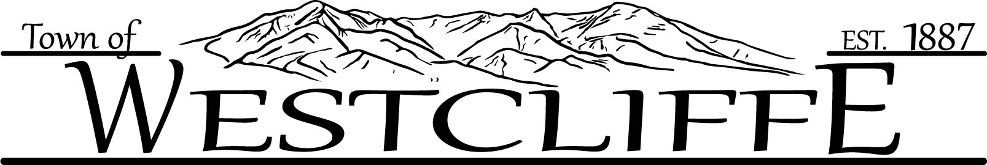

PROGRAM OVERVIEW
Our Town Trustees know that the appearance of the commercial buildings in downtown Westcliffe is critical for assuring downtown and the entrances into town are vibrant and inviting to community members, visitors, and investors. The Business District Facade Program assists businesses and business property owners in making aesthetic improvements to their buildings, such as signs, awnings, painting, landscaping, etc., through matching grants. This program strengthens and promotes economic development in Westcliffe's downtown business district.
Either property owners or business owners are eligible for funding. When business owners are not property owners, both persons/entities will be co-applicants. The maximum grant amount is
$5,000 with a $1,000 minimum. Grant awards shall be at the discretion of the Town Grant Committee and will generally be a 1-for-1 match. Funding is limited to a maximum of $25,000. Preference will be given to applicants who have not previously received funds. Applicants are encouraged to submit requests as early in the year as possible.

BUSINESS DISTRICT AREA
Properties must be in the following areas, listed relative priority areas:
Priority Area A:
- Main Street from Bassick Place to Adams Blvd.
- Third Street from North Ave. to the alley on the east and west side of South Third Street.
- Second Street from North Ave. to Rosita Ave. Priority Area B:
- Rosita Ave. from Second Street to Adams Blvd.
- North Ave. (Hwy 69 North) from Main Street to Town Limits
- North Ave. (Hwy 69 South) from Main to Town Limits

GRANT COMMITTEE
The Board of Trustees will review all grant applications to develop and finalize funding determinations. If you have questions regarding the Westcliffe Business Facade Program, please get in touch with the Town Administrator/Clerk's Office at (719)783-2282.

GENERAL GUIDELINES:
- Grants are for significantly improving the exterior aesthetics of properties as seen from the streets and sidewalks of the streets listed above to qualify.
- Proposed site improvements must meet all current Town codes.
- The applicant is responsible for obtaining any applicable building and other required permits before project work commences.
- Exterior improvements only must be visible from the public right-of-way and other public areas and parks. Examples include, but are not necessarily limited to:
  - Window and door
repair/replacement f. Siding repair/replacement
  - Entrance improvements g. Landscaping
C. Awnings and canopies h. Signage
- Masonry work i. Lighting
- Painting

- Repairs that are structural in nature are generally not eligible for grant funding but may be evaluated on a case-by-case basis if such repairs are necessary to enhance the exterior's aesthetics.
- Grant funds will be provided to a business upon project completion. Upon completion of the grant project, a business must provide copies of all paid invoices or other evidence of payment to receive grant funds.
- Grant funds must be used, and documentation for reimbursement must be submitted no later than December 31st of the year the grant was awarded.
- Projects selected for grant funding may be featured in Town promotional materials.
- Grant funding is NOT available for the purchase of tools, machinery, or equipment or the owner's time spent on the project.

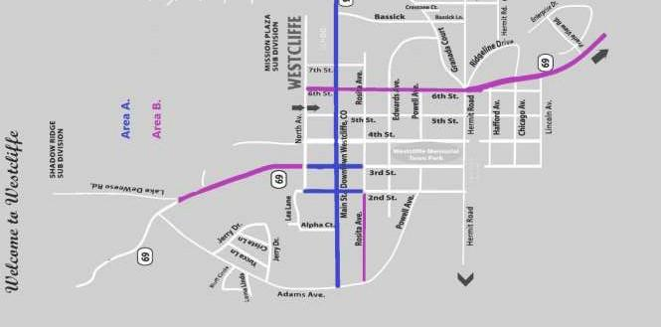

WESTCLIFFE BUSINESS FACADE GRANT APPLICATION FORM
-
Business Name: | Phone:
Lead Contact Person: | Title:
E-Mail: | Website:
Mailing Address: | Physical Address:
Business Owner: | Property Owner:
Grant Request Amount: | Total Project Cost:

PROJECT SUMMARY:

Four copies of the printed application, attachments, and support material must be received to be considered for review. Instructions for SUMMARY or attached Project Narrative and Plans:
- Describe how the proposed project will provide a significant visual improvement over current conditions as seen from public ways.
- Provide relevant information such as project budgets, construction proposals, bids, photographs, site plans/sketches, project schedules, and required permits at the applicant's expense
- Please provide paid receipts and proof of payment for reimbursement upon completion of the project.
- Note any factors that pose a risk to the completion of the project within six months of award.

All applicants are encouraged to review their proposed projects with Town staff before application submission to fully understand any Town codes relevant to a particular project. Incomplete applications will not be accepted.

The grant application is due by February 27^{th,} 2026, by 5:00 p.m. They may be dropped off at the Westcliffe Town Hall, 1000 Main Street.

Applicant's Signature Date

Building Owner's Signature (if different from applicant) Date

